**Customer Retention Project**

Prelude:

In modern times, e-retailers are emerging business. In these types of business there are vendors or product suppliers and end user customers. E-retailers acts as a bridge between them. Providing ease, convenience and flexibility to both the parties,

e-retailers are gaining importance.

In the given dataset we are provided with the knowledge of factors influencing a shopper to induce in brand loyalty of an e-retailer.

Problem Statement:

We have to build a classification model to predict whether a user does a repeat purchase.

About the Data:

- The schema of the dataset is 71 columns and 269 rows

- There are no missing values

- Except the "Pincode" column all the columns are of object type

-There are duplicate entries

-There are skewness and outliers present in the data

Visualization:



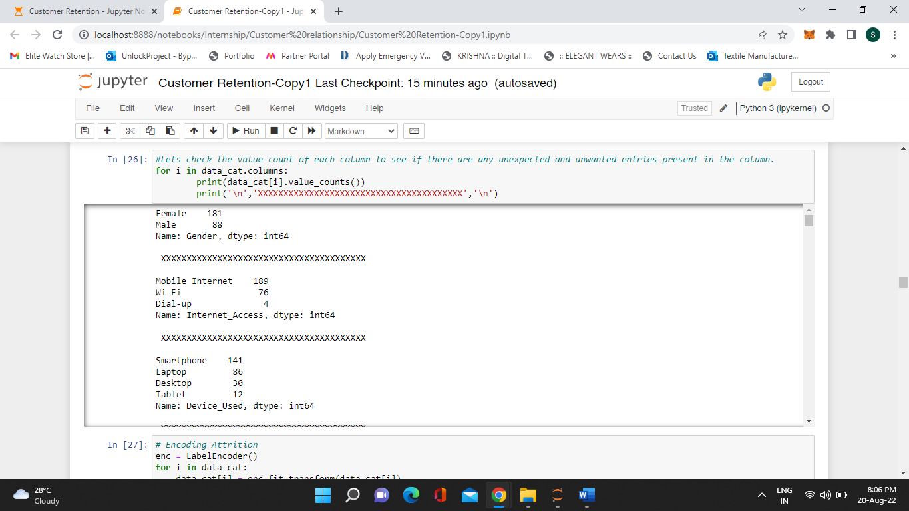

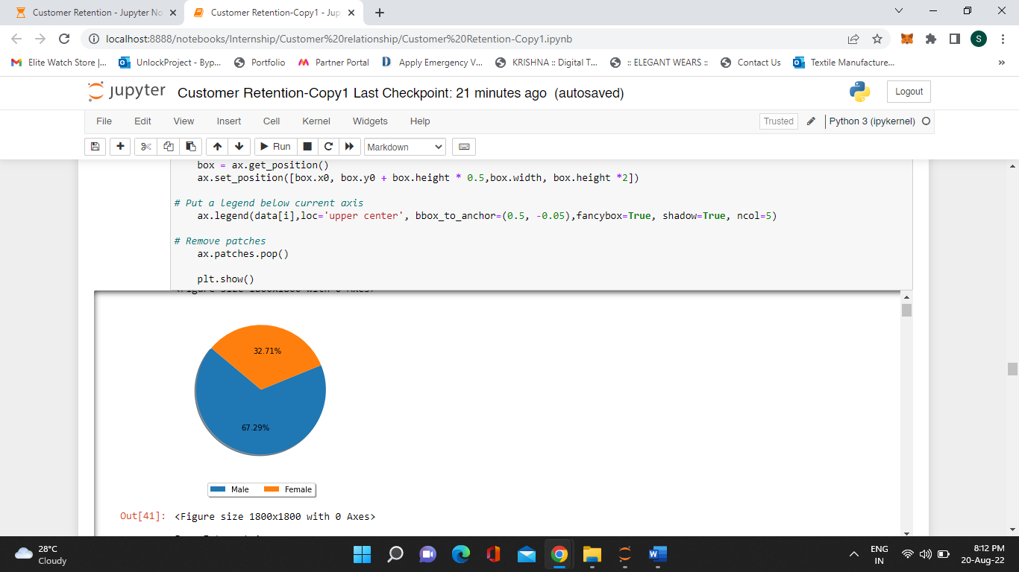Findings

- There are more females (67.29%) than males(32.71%) for shopping online.

- The maximum shoppers are from 31-40 years (30.11%), closely followed by 21-30 years (29.37%) and least is of 51 years and above (7.06%). The reason can be due to lack of tech-savvy age group.

- Maximum online shoppers reside in Delhi (21.56%) followed by Greater Noida (15.99%) and least being Bulandshahr (0.74%). However, if we take the Noida and Greater Noida areas then they constitute (30.86%) of the shoppers.

- Maximum shoppers reside have pin code 201308 (14.12%)

- Maximum shoppers are people who have done online purchase for more than 4 years (36.43%) and the least are between 1 and 2 years of online shopping experience (5.95%). However, we see a spike in online shopping promising a good number for business in future.

- 42.38% of shoppers have done less than 10 times shopping through online channel. Whereas, most frequent shoppers say 42 times and above only constitute 2.23%. This indicates people are slowly inclining to online shopping

- 52.79% of shoppers use their mobile internet connection for shopping. Least shoppers, use Dial-up connection 1.49%

- 52.42% of shoppers use their smartphones for shopping. While the least frequent device used happens to be tablet (4.46%)

- The above two points tell us that convenience happens to be a vital factor to increase the frequency for online shopping as our mobile phones are usually with us even on the go.

- Maximum shoppers have different screen (49.81%) size of the device they use for shopping. but bare minimum screen size preferred by the shopper is 5.5 inches (36.80%).

- Maximum shoppers use windows (45.35%) as the operating system for their device and least used is iOS/MAC (23.05%)

- Maximum shoppers use Google Chrome browser (80.30%) for shopping, while minimum used browser is Mozilla Firefox (1.86%). This could be due to popularity of google chrome.

- Maximum shoppers use search engines (85.50%) to arrive at a shopping e-portal for the first time

- Maximum shoppers use search engines (32.34%) to arrive at a shopping e-portal next time. However, the e-retailer's app (31.97%) and direct URL (26.02%) is followed closely for the shopper’s consequent visit. Social Media happens to be least influencer for a buyer to make a repeat purchase by the same e-retailer. This shows that the buyer is gaining trust and inclined more towards particular e-retailers.

- The shoppers spend more than 15 minutes (45.72%) in the e-retailer's shopping platform before making the purchase. Whereas, impulsive buyers constitute only (10.78%). This points out that shoppers do their research before buying the product. Perhaps a feature which could help them in comparing the similar products to the one a buyer wants can help them save time and increase loyalty towards a particular e-retailer.

- Maximum shoppers use their Credit/Debit cards (55.02%) to make an online purchase while, least use e-wallets (16.73%). The ratio of pre-paid to post-paid is 193:76. This shows that 71.75% of shoppers have complete faith on online shopping. Therefore, tie-ups with banks and e-wallet providers in providing some additional incentives can be beneficial for the e-retailers.

- According to the data provided, shoppers show a greater tendency to abandon the cart (sometimes, frequently and very frequently all combined- 82.16%) than to make a confirmed purchase (never-17.84%).

- The prime most reason for abandoning the card happens to be that shoppers are lured to better alternative offer (49.44%). In broader sense, it comprises about half the time. Least factor influencing abandoning of the cart by a shopper is the e-retailer not having the shopper's preferred mode of payment (5.20%).

- It is necessary for the content on the site must be easy to read and understand.

- Majorly shoppers in their research compare the product they wish to purchase with the similar product.

- Complete information about the seller is equally important to detailed information of the product for buyers to make a purchase.

- Site/app must be easy to navigate and more user-friendly.

- The site/app must have a good loading and processing speed as the buyer's don't like too much time waiting for the page to load

- Majority of the shoppers prefer convenient payment method

- Trust is a major component for the shoppers to make a purchase online

- Maximum shoppers prefer responsiveness and availability of several communication channels (email, online rep, twitter, phone etc.)

- Maximum shoppers prefer e-retailer to keep the privacy of their patrons secured.

- Maximum shoppers are lured to stay loyal if the e-retailers provide monetary benefit and discounts to their users.

- 53.90% shoppers feel enjoyed while shopping online, providing them a good experience to engage in loyalty

- Majorly the shoppers think online shopping is convenient and flexible

- The return policy is very important for the purchaser to be loyal to any e-retailer

- Maximum shoppers prefer gaining access to loyalty programs conducted by the e-retailers provides add-on benefits

- Majority people agree to quality information being displayed on the page improves customer satisfaction and minimum are indifferent, however, nobody disagrees.

- Majority people derive satisfaction by shopping on a good quality website or application.

- Majority people agree to net benefits derived from shopping online can lead to customer satisfaction,

- 88.85% users agree that satisfaction can only exist if the user has trust on the e-retailer

- About 3/4th of the users is of the opinion that variety and wide range of products help the e-retailers to sustain customer loyalty

- Maximum users agree that providing complete and relevant information about the products is very necessary for a purchaser to buy a product online.

- Maximum users engage into monetary benefits provided by the e-retailers.

- Maximum people agree to online retailers provide convenience of shopping, few seems indifferent but none disagree.

- Maximum users agree that online shopping gives a sense of adventure. This maybe because there's no physical store and money is being involved in the transaction.

- There is a very close call between users feeling sense of enhanced social status being associated with their preferred online store and being indifferent to be associated with their favourite online store.

- There is a very close call between users feeling sense of gratification being associated with their preferred online store and being indifferent to be associated with their favourite online store.

- Maximum users feel a sense a of role accomplishment by shopping online.

- Majority people get money worth deals online; few are indifferent but none disagree.

- As per the dataset, every user has shopped on amazon.in, followed by paytm.com and flipkart.com

- As per the dataset, every user finds amazon.in to be the easiest website to browse, followed by paytm.com and flipkart.com

- There's a very close call between Flipkart.com and Amazon.in to be visually appealing.

- There's a very close call between Amazon.in and Flipkart.com to be having wide variety of products.

- Maximum users find details posted about the products to be relevant and complete on amazon.in

- Maximum users find amazon.in to be fastest loading website & application.

- Maximum users find amazon.in to be most reliable website & application.

- Maximum users find amazon.in to be quickest website & application for the purchase of product.

- Amazon.in provides maximum channel partners to facilitate payment.

- There's a very close call between Amazon.in and Flipkart.com for speedy order delivery.

- Amazon.in and Flipkart.com scores most in customer information privacy.

- Amazon.in provides maximum security for customer's finances.

- Amazon.in is perceived as the most trustworthy, followed by flipkart.com.

- Amazon.in has the most online assistance presence through multiple channels.

- Amazon.in takes the longest time to get the user logged in due to promotions, sales etc. This can be a turn-off for the user.

- Amazon.in takes the longest time to display graphics and photo due to promotions, sales etc. This can be a turn-off for the user.

- Myntra.com scores maximum in delay for display of price followed by Paytm.com. whereas, amazon.in, flipkart.com and snapdeal.com are the quickest in displaying price.

- Myntra.com and amazon.in takes maximum time in loading the page due to offers, promotions and sales advertisements. Whereas snapdeal.com is the quickest to load.

- Snapdeal.com has the most limited channels for the payment.

- Paytm.com has the longest delivery period according to the users in the dataset.

- Amazon.in scores the most for change in website/app whereas, snapdeal.com scores the least.

- Amazon.in provides frequent disruption while navigating pages mainly due to ads and promotions whereas, paytm.com provides least disruption.

- Amazon.in is the most efficient website as per user ratings and snapdeal.com is the least efficient.

- Amazon.in is the most recommended website/app and paytm.com is the least recommended.

- Female are doing more shopping compared to men and females with age group 21-30 and men of age group 31-40 are shopping more than other age groups.

- There are more customers in Great Noida and they belong to above 4 years of online shopping experience.

- Maximum customers using the e-retail shop for more than 15 mins to make purchase decision and max customers uses credit/debit card as payment option.

Conclusion:

After conducting a thorough research, we learn about the factors influencing the success of an online retailer. Trust from customers forms the base for any business and online e-retailers are no exception. Apart from trust, complete information on products as well as the seller, ease in navigation, faster loading along with appealing user-interface, wide range of products and payment channels and lastly, return policy scores most for success of an e-retailer. As per the data, Amazon.in is at the top in the business and has the best mix of the variables needed for the success. Second position belongs to flipkart.com. Additional benefits like discounts loyalty programs only lure an end-user to remain loyal to the e-retailer. Paytm.com and Snapdeal.com shows signs of high alert and if not improved with their problem areas they might perish. Conversely, when a customer is enjoying the service of a particular e-retailer he/she will recommend it to their circle and in return enabling the e-retailer to tap more market.

Further, all model is tending to overfit. However, I am choosing decision tree classifier as the best fit model.